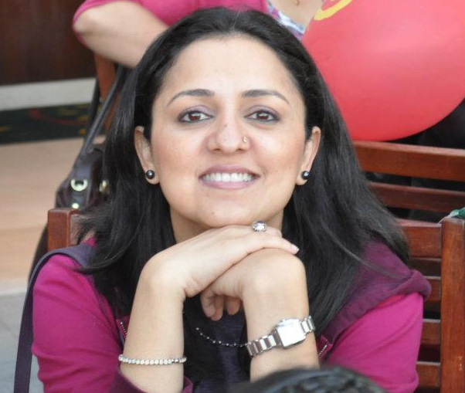

S h a h a n a R a z a

Producer-Writer
Published Book ‘Off the Beaten Track: The Story of My Unconventional Life’

M: 050-2106162 E: shahanaraza@gmail.com

Experienced professional with demonstrated history of working on projects from start to finish, independently, as well as within a team to achieve compelling creative results.
S K I L L S

- Highly proficient in spoken and written English as well as Hindi
- Excellent communication and leadership skills
- Can effectively manage multiple projects at various stages of execution and production
- Organized & Pro-active
- Adaptable & Reliable

Professional Experience

P R O D U C E R

Broadcast
- Expo 2020 Dubai, Dubai Media Incorporated: August 2021 to Current
- Produce creative as well as newsworthy content as VNR’s (Video News Report) and Segments at Expo 2020 Dubai, covering a wide range of topics, along with exceptional creative features after scouting for out-of-the-box ideas at this mega international event.
- Manage and direct crew in the field and on set while maintaining schedule.
- Develop, shoot and oversee edits from start to finish meeting all deadlines and submitting all requisite paperwork.
- Produce both long and short form videos from 2 to 52 mins duration.
- Write scripts for Daily and Weekly highlights.
- Adept at using multiple cloud-based platforms and Apps such as Monday.com, Frame IO, Sonix and the PAM-MAM systems in broadcast to ensure workflow runs smoothly and efficiently.
- Hands-on experience with performing rough edits on Avid and Premier Pro.

Digital Media
- Vietnam TV, Abu Dhabi: September 2021 to current
- Co-ordinate, organize and schedule film shoots with various clients across UAE to produce digital broadcast content.
- Pitch and brainstorm new ideas with Bureau head.
- Liaise professionally with various businesses to ensure deadlines are met and the interview/filming process is executed smoothly.

- Milkshake Media, Dubai: January to March 2019
- Script and Produce interesting videos as content for Star TV’s Biwi’s Day Out-2 contest.
- Research background of participating candidates to prepare questionnaire for interviews.
- Oversee post-production edits ensuring all collaterals work cohesively to produce outstanding end results.

- MyDubaiMyCity & NewYou Journal, Dubai: February 2013 to 2016
- Overseeing all aspects of production, as creative lead, I researched, scripted and directed multiple video films to produce inspiring web content on a variety of subjects.
- Researched to selected right candidate/s for the projects after extensive fact finding.
- Completed reconnaissance during pre-production to streamline shooting.
- Liaised, planned and completed shoots successfully ensuring deadlines are met.
- Coordinated and communicated with subjects and crew during production.
- As Supervising Editor, generated ideas for attractive graphics and created subtitles during post-production.
Radio
- Arabian Radio Network (101.6 FM): November 2011 to August 2012
- As Newsreader and Reporter, wrote local and international news reports while simultaneously scouring wires to select stories for the daily bulletin.
- Planned and scripted English and Hindi news bulletins, including Breaking News stories.
- Edited the news bulletins using relevant software used in Radio newsroom.
- Read the English and Hindi news for 101.6 FM.

W R I T E R

Content, Social Media, Copywriter

- Sharjah Children’s Reading Festival, NNC PR: September 2020 to July 2021
- Created precise and informative Press Releases at the globally renowned 11-day event which were shared with both local and regional media.
- Conducted impromptu in-person interviews to create pressers with a short turn-around time.
- Attended various Live sessions and ongoing events to write concise and effective PR pieces.

- Social Media Copywriter, Gozoop, Dubai, July to October 2019
- Researched and created social media content in the form of short, crisp ‘Copy and Image’ posts for a wide range of clients from the health, banking, lifestyle sectors, including jewelry brands.
- Ensured tone of posts was individualistic for each brand and in-sync with the requirement of the social media it was being written up and created for, which could be from casual to formal.

- Insignia Advertising Agency, Dubai: January 2011 to April 2011
- Performed diverse corporate communication functions creating short-form and long-form copy for several luxury, travel and lifestyle brands.
- Developed compelling content for websites according to guidelines provided.
- Created relevant copy for brochures, including Dnata Travel Brochure.
- Planned and drafted several radio ads for clients.
- Researched, scripted & directed corporate film for Al Maya supermarket chain.

Journalist – Author

- Translated memoir of India’s First Woman Radio Newsreader: October 2020
- Originally written in Urdu, 'Off the Beaten Track: The Story of My Unconventional Life' is the fascinating story about the life and times of Saeeda Bano, India's first woman radio newsreader. It has jointly been published by Penguin India and Zubaan Books.
Media Links: https://linktr.ee/shahanaraza

- Freelance Journalist: Sept 2010 to May 2017:
- Writing and researching features stories which have been published in Gulf News ‘Tabloid,’ and ‘Friday’ magazines, Khaleej Times ‘Inspired Living’, the NewYou magazine and REPS magazine.
- Creating relevant, fresh and engaging content on a wide range of topics including health and wellbeing, lifestyle, local news stories, self-help and interior design, personality profiles.
- Generating original ideas for stories that appeal to various age groups and/or the targeted audiences.
- Conducted focused interesting interviews to enhance content and make it more engaging.
- Researched interesting facts that strengthen the appeal of the article.
- Pitched and brainstormed new ideas with commissioning Editors.
- Ensured submission deadlines are met successfully.
It’s 'Tinder for mums': This Dubai expat built an app to help fellow mothers &
https://fridaymagazine.ae/life-culture/people-profiles/what-it-takes-to-be-successful-1.2312917

* Work Experience prior to 2010 not included

Education

- 1991 – 1993: Master of Arts in Film & Video Production.
AJK Mass Communication Research Center, New Delhi, India.
- 1989 – 1991: Bachelor of Arts in English Literature.
Delhi University, India.

Awards

- Best Documentary Award in Asian Academy Awards ’97 for
` A Eunuch called Sunita.’
- Silver Award - 38th World Festival held in Houston, USA, for
` A Eunuch called Sunita.’

***

